**Future of Mobility: How Renewable Energy Drives Electric Vehicles Adoption**

**Group 5** :***Nivas Marudhavanan, Mithran Pichaya Kumaran, Navya Manjunatha, Jennithra Srinivasan***

**Abstract**

The electrification of vehicles is vital for achieving global climate targets and advancing sustainable transportation. Electric vehicles (EVs) offer a cleaner alternative to fossil-fuel-powered vehicles, particularly when powered by renewable energy. This project examines the factors influencing EV adoption, including energy consumption patterns, renewable energy integration, and carbon intensity. Using data from the "Our World in Data" repository and machine learning techniques, the study predicts EV adoption likelihood and explores how renewable energy enhances readiness for EV integration, offering insights to support sustainable mobility transitions.

**Introduction**

Electric vehicles (EVs) play a key role in reducing greenhouse gas emissions and combating climate change. However, EV adoption varies across countries due to differences in energy consumption patterns, electricity, carbon intensity, and renewable energy integration. This study analyzes these factors to predict EV adoption and explores the correlation between renewable energy usage and EV readiness, providing actionable insights to accelerate the global shift to sustainable transportation.

**Problem Statement**

Develop a predictive model to forecast the adoption rate of electric vehicles (EVs) in the coming years, leveraging energy consumption patterns, renewable energy integration, and carbon intensity data. Complement this analysis with Tableau visualizations to identify countries at the forefront of renewable energy adoption and explore how their renewable energy share correlates with EV adoption metrics. Additionally, use Power BI to analyze which renewable energy sources, such as solar, wind, or hydro, play the most significant role in supporting EV infrastructure. This model and the accompanying dashboards aim to provide actionable insights into the readiness and factors driving the global transition to sustainable transportation.

**Research Questions**

**ML Model:** How has the consumption of renewable energy evolved in recent years, and what implications could these trends have on the adoption of electric vehicles (EVs)?

**Tableau:** Which countries are at the forefront of renewable energy adoption, and how does their renewable energy share correlate with electric vehicle (EV) adoption metrics?

**Power BI:** Which renewable energy sources (e.g., solar, wind, hydro) play the most significant role in supporting EV infrastructure?

**[1] Methodology For Model Building:**

**Data Collection:** The dataset for this analysis, sourced from Our World in Data ([ourworldindata.org/energy](https://ourworldindata.org/energy)), contains 129 features and 21,812 entries, providing a comprehensive view of global energy consumption trends. For our model, we focused on key energy sources: **coal**, **gas**, **oil**, **renewables**, and **nuclear consumption**. This subset captures critical patterns in energy use, enabling targeted analysis of consumption trends across diverse energy types.

**Feature Engineering:** To prepare the data for modeling, we began with preprocessing by identifying null values in each column and calculating their missing percentages. Columns with more than 80% missing values were dropped to ensure data quality. Next, we visualized the data distribution using histograms (refer to Appendix 1) to assess whether features were normally distributed or skewed, enabling appropriate normalization. To address outliers, box plots were created for key features (refer to Appendix 3), and outliers were removed where necessary. Finally, the remaining missing values were imputed using the KNN imputation method to maintain data consistency.

**Visualization:** To address the research question [1] we first created a scatter plot (Appendix 4) to explore the relationships between GDP, energy consumption, and electric demand, helping us understand the potential factors driving EV adoption. To analyze energy consumption trends from 1900 to 2020 (Appendix 5), we visualized how energy usage has evolved over time, providing insight into how these trends could impact future energy consumption and EV adoption . We also examined correlations between our model's features using a heatmap (Appendix 7) to understand how they relate to each other. To compare energy consumption from various sources, a bar chart (Appendix 7) was used to display which energy sources are most heavily utilized. We then created a chloropleth map (Appendix 8) to show carbon intensity levels by country, suggesting that countries with lower carbon emissions could more quickly adopt EVs. Finally, by visualizing the top 10 countries using renewable versus non-renewable energy sources (Appendix 9), we inferred that nations with a stronger reliance on renewable energy are more likely to transition to EVs faster, while those dependent on non-renewable sources like coal, oil, and gas may face slower adoption.

**Model Chosen:** We selected a time series model given the dataset's time-based features. To ensure the data is suitable for modeling, we performed the Augmented Dickey-Fuller (ADF) test, which checks for stationarity. Stationary data is essential for time series models like ARIMA, SARIMA, and machine learning methods because it helps improve forecasting accuracy. The ADF test results show all key features are stationary . These results confirm no further transformations are needed. The ACF and PACF plots (Appendix 10) show strong autocorrelation at lag 1 for most features, indicating short-term dependencies, with nuclear consumption exhibiting longer-lasting correlations.We chose **LSTM (Long Short-Term Memory)** over ARIMA for model building due to LSTM's ability to capture complex, nonlinear relationships, handle long-term dependencies, and process large datasets effectively. These strengths make LSTM more suited for our data. From **Appendix 11 Model Outcome)**, we observe a spike in renewable energy consumption, while other energy sources remain steady or decline. If this trend continues, EV adoption rates are likely to rise in the coming years. **Appendix 12** indicates the LSTM model is performing well and is expected to make accurate predictions on new data, further validating its effectiveness.

**Hypothesis Test**

Test for Stationarity of Time Series Data

**Null Hypothesis (H0):**  
The time series data (for all energy sources) is non-stationary.

**Alternative Hypothesis (H1):**  
The time series data (for all energy sources) is stationary.

### Test Method:

We performed the **Augmented Dickey-Fuller (ADF) Test** for each energy consumption time series (coal, gas, oil, renewables, nuclear consumption) to test for stationarity.

**Results and Inferences:** We performed the Augmented Dickey-Fuller (ADF) test to assess the stationarity of time series data for various energy consumption sources (coal, gas, oil, renewables, and nuclear). The null hypothesis (H0) posits that the data is non-stationary, while the alternative hypothesis (H1)) suggests it is stationary. The test results showed p-values significantly less than 0.05 for all energy sources: coal consumption (9.12e-29), gas consumption (1.59e-28), oil consumption (3.88e-29), renewables consumption (1.58e-26), and nuclear consumption (0.0), allowing us to reject the null hypothesis and we conclude The time series data (for all energy sources) is stationary.

**Conclusion**

The analysis shows a significant increase in renewable energy consumption over the next five years, as predicted by the LSTM model. This trend suggests that if renewable energy consumption continues to grow at this rate, electric vehicle (EV) adoption will likely accelerate, as the alignment between renewable energy and EVs supports environmental goals. The findings imply that, in the coming years, renewable energy growth could play a key role in driving higher EV adoption rates globally.

### [2] Dashboard Development in Tableau: Analyzing the Correlation Between Renewable Energy Adoption and Electric Vehicle Metrics Across Leading Countries in Tableau (Appendix 13)

**Data Preprocessing**

To ensure clean and accurate analysis, null values in the dataset are filtered out using Tableau's built-in tools. This ensures that only complete and relevant data is used for visualizations.

**Renewable Energy Share by Country**

A map visualization is created to rank countries by their renewable energy share. The map uses a range slider to dynamically show rankings, with a gradient from light blue (high renewable energy share) to orange (low renewable energy share). This visualization allows for quick identification of countries leading in renewable energy adoption, offering insights into their potential for EV adoption.

**Top 10 Countries in Renewable Energy**

A bar chart highlights the top 10 countries with the highest renewable energy shares. This provides a focused view of the leaders in renewable energy, enabling deeper analysis of their policies and infrastructure investments.

**Correlation Between Renewable Energy and EV Adoption**

A scatter plot is developed to examine the relationship between renewable energy share and EV adoption metrics. This plot reveals how renewable energy infrastructure aligns with the readiness and adoption of EVs, shedding light on the role of clean energy in sustainable transportation strategies.

**Energy Consumption Trends Over Time**

To understand the evolution of energy consumption, a combination of bar and line charts is created to visualize trends over the years. These charts provide context for the progress of renewable energy integration and its alignment with global sustainability goals.

**Top Country Performance by Energy Source**

Finally, a bar chart is used to depict the performance of top countries across various energy sources, including renewables, fossil fuels, and nuclear. This comparison highlights the energy profiles of leading nations and their strategies in diversifying or transitioning their energy mix.This comprehensive Tableau dashboard provides a detailed understanding of the interplay between renewable energy adoption and EV readiness, offering actionable insights for policymakers and industry stakeholders.

**Conclusion**

Countries leading in renewable energy adoption, as highlighted through Tableau analysis, demonstrate a strong alignment with EV adoption metrics. These nations showcase the potential of renewable energy integration to support sustainable transportation. The correlation between high renewable energy shares and EV readiness underscores the importance of clean energy investments in advancing global EV adoption efforts.

### [3] Dashboard Development in Power BI: Analyzing the Role of Renewable Energy Sources in Supporting EV Infrastructure Using Power BI (Appendix 14)

**Leading Renewable Energy Source - (Appendix 14)**

A **Card Visualization** identifies hydro as the leading renewable energy source contributing to EV infrastructure. This insight is derived using a DAX formula to calculate the maximum renewable source, providing clarity on the dominant contributor.

**Renewable Electricity Share**

A **Card Visualization** is used to display the share of renewable electricity, calculated through a DAX measure. This metric is further broken down by year, enabling a detailed understanding of temporal trends in renewable energy adoption.

**Peak Year in Renewable Energy Contribution**

Another **Card Visualization** highlights the year with the highest renewable energy contribution. This helps track peak performance and provides a benchmark for assessing progress in renewable energy initiatives.

**Renewable Energy Target Progress**

A progress tracker in the form of a **Card Visualization** shows how much of the renewable energy target has been achieved. This measure, formatted as a percentage, serves as a key performance indicator for stakeholders aiming to meet sustainability goals.

**Geographical Analysis with Map Visualization**

A **Map Visualization** showcases renewable energy production by country, offering a geographic perspective on energy contributions. This enables a clear comparison of renewable energy adoption globally.

**Donut Chart of Renewable Energy Sources**

A **Donut Chart** visualizes the proportional contributions of various renewable energy sources, such as solar, wind, and hydro, to total electricity generation. Interactive slicers for year or country add flexibility to explore variations dynamically.

**Funnel Chart for Energy Transition Analysis**

A **Funnel Chart** illustrates the progression from total renewable energy consumption to contributions by specific sources. It highlights bottlenecks or inefficiencies, providing actionable insights into the energy transition process.

**Hydro Electricity by Country**

A **Stacked Bar Chart** visualizes hydroelectricity contributions by country. Breaking down this data by year using a legend provides a color-coded representation of changes over time.

**Total Renewable Electricity**

A **Gauge Chart** represents total renewable electricity generation. With a clear target value and performance thresholds, this visualization tracks progress toward renewable energy goals.

**Line Chart for Renewable Source Contributions Over Time**

A **Line Chart** displays the yearly contributions of different renewable sources, enabling a comparative analysis of trends in solar, wind, and hydroelectricity generation.

**Ribbon Chart for Renewable Energy Dynamics**

A **Ribbon Chart** captures the relative contributions of renewable energy sources over time, with dynamic ribbons showing year-over-year changes and proportions of total energy from each source.

**Conclusion**

The Power BI dashboard offers a comprehensive view of renewable energy contributions to EV infrastructure. Through a variety of visualizations, including card visuals, maps, and line charts, it highlights key metrics such as renewable electricity share, target progress, and country-level hydroelectricity contributions.

**Lesson Learned from this Course**

**Visit this site to explore our class journey** : <https://amber-katuscha-54.tiiny.site/>

Throughout our entire semester on the Data Visualization journey, we documented it in a blog-like format with a formal color scheme.

**Bibliography**

1. <https://www.kaggle.com/learn/time-series>
2. <https://www.analyticsvidhya.com/blog/2021/10/a-comprehensive-guide-to-time-series-analysis/>
3. <https://www.datacamp.com/tutorial/arima>
4. <https://www.analyticsvidhya.com/blog/2021/03/introduction-to-long-short-term-memory-lstm/>
5. <https://datascience.stackexchange.com/questions/12721/time-series-prediction-using-arima-vs-lstm>
6. <https://www.datacamp.com/tutorial/tableau-dashboard-tutorial>
7. <https://www.datacamp.com/tutorial/tableau-dashboard-tutorial>

**Source Code**

**ML Model Code:** <https://colab.research.google.com/drive/1F3coR6qG3EZAaZAND4SeKLnIoQz2L4r5>

**Tableau:** <https://public.tableau.com/app/profile/nivas.marudhavanan/viz/Project_Research_Dash/Dashboard1>

**PowerBi:** <https://app.powerbi.com/reportEmbed?reportId=212e7553-c1c2-4dab-9bf3-3b3104acd516&autoAuth=true&ctid=5cdc5b43-d7be-4caa-8173-729e3b0a62d9>

**Appendix**

**[1]**

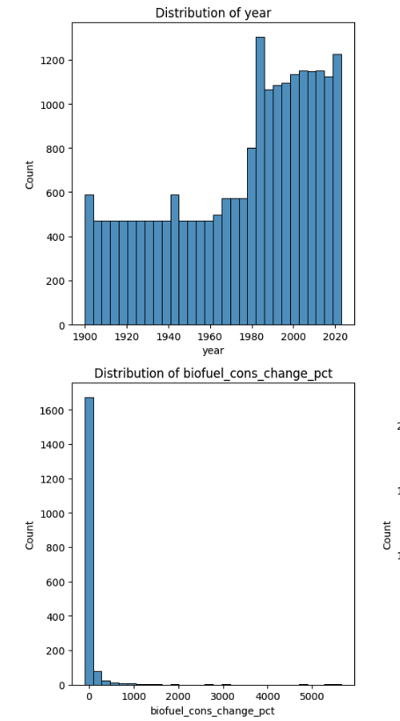

**[2]**

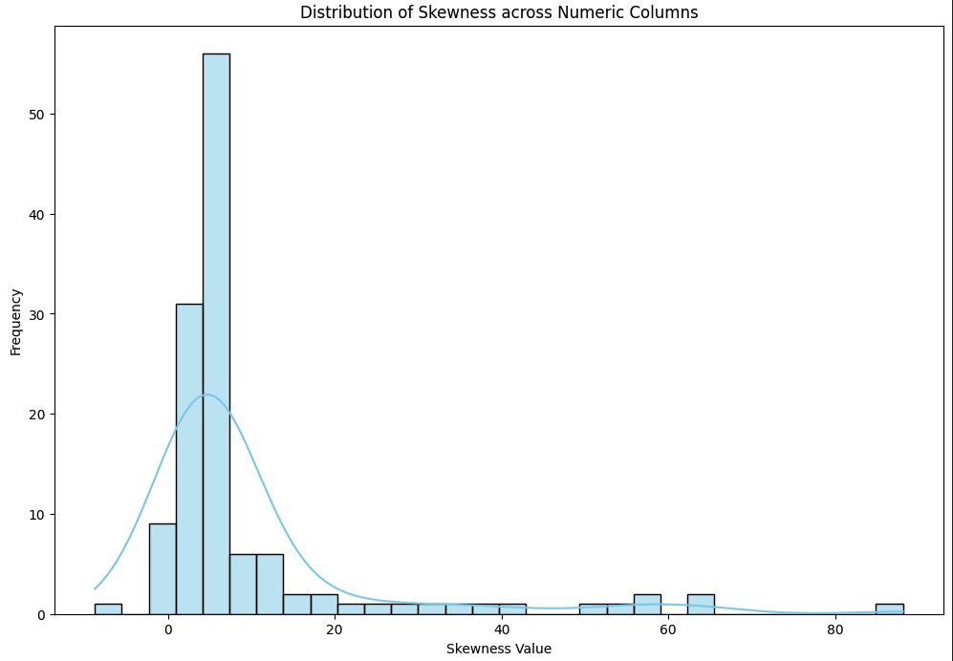

**[3]**

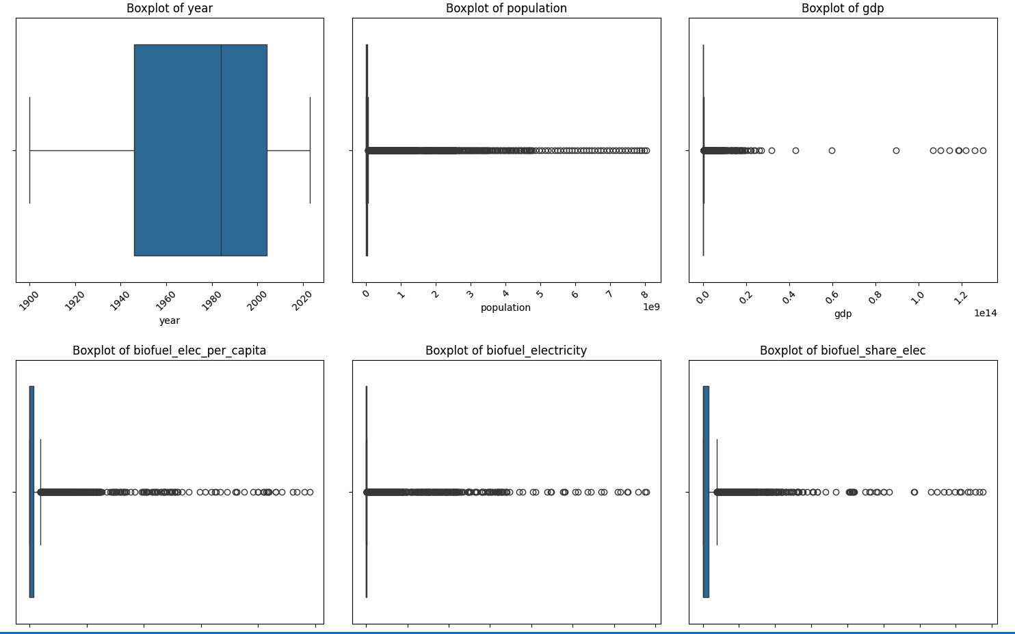

**[4]**

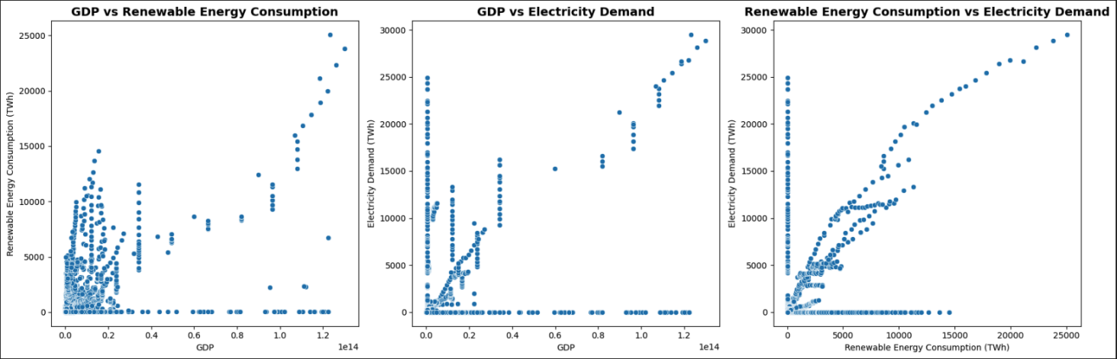

**[5]**

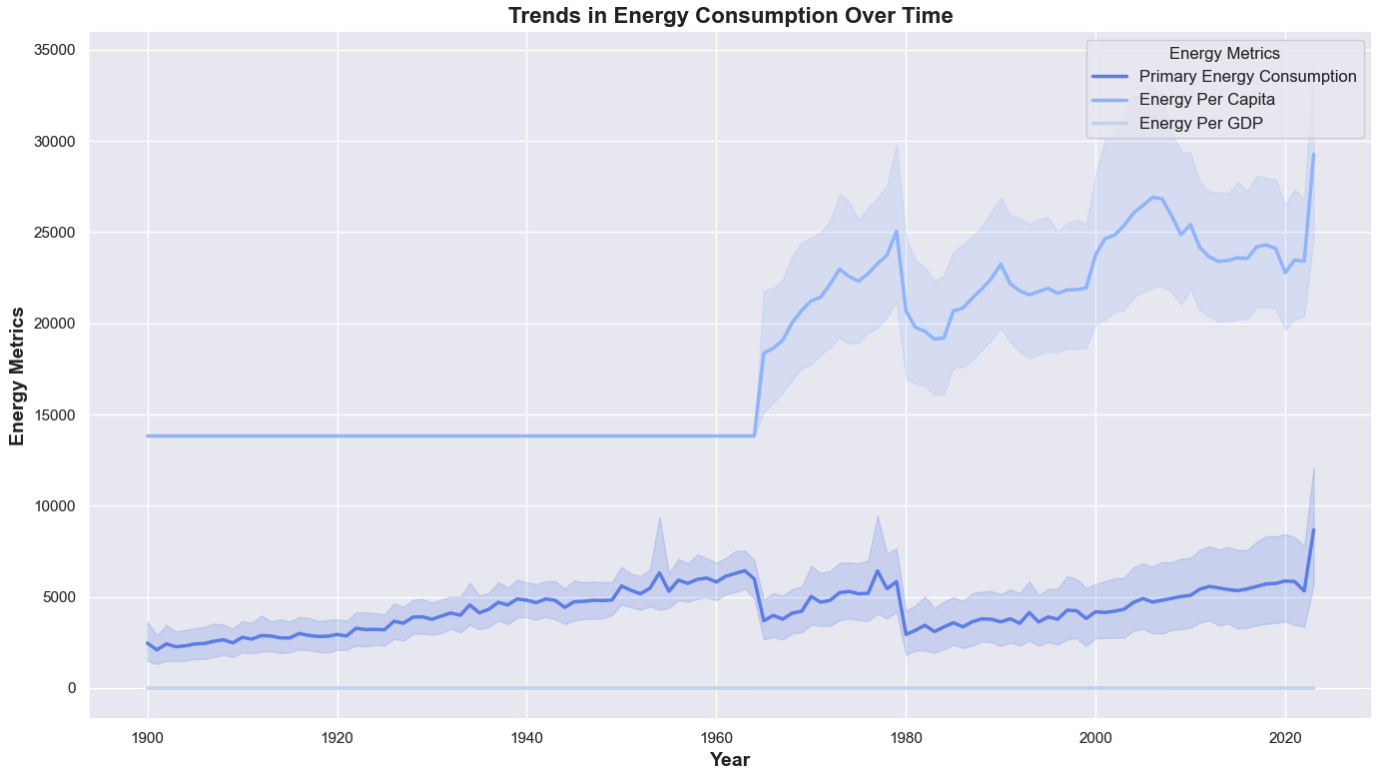

**[6]**

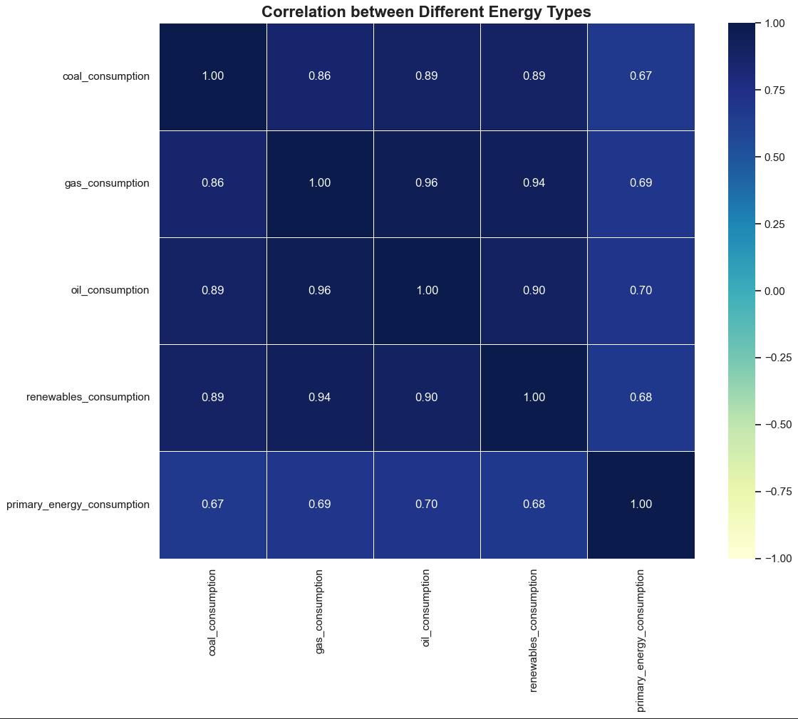

**[7]**

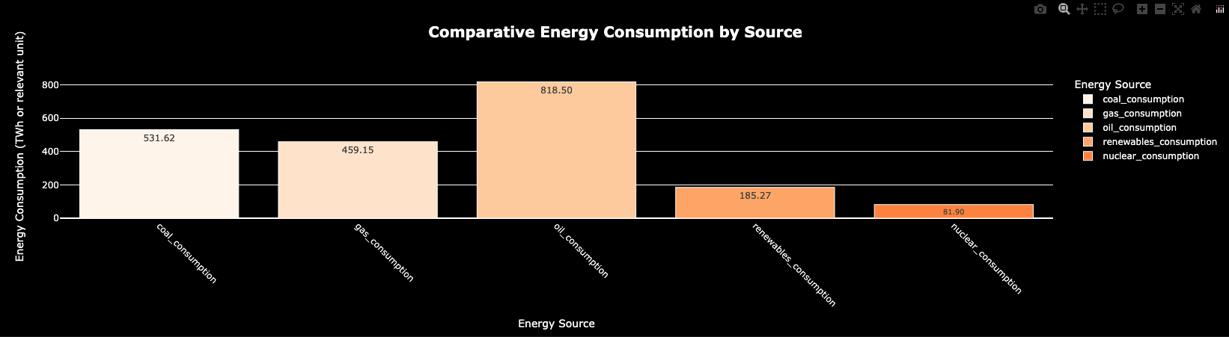

**[8]**

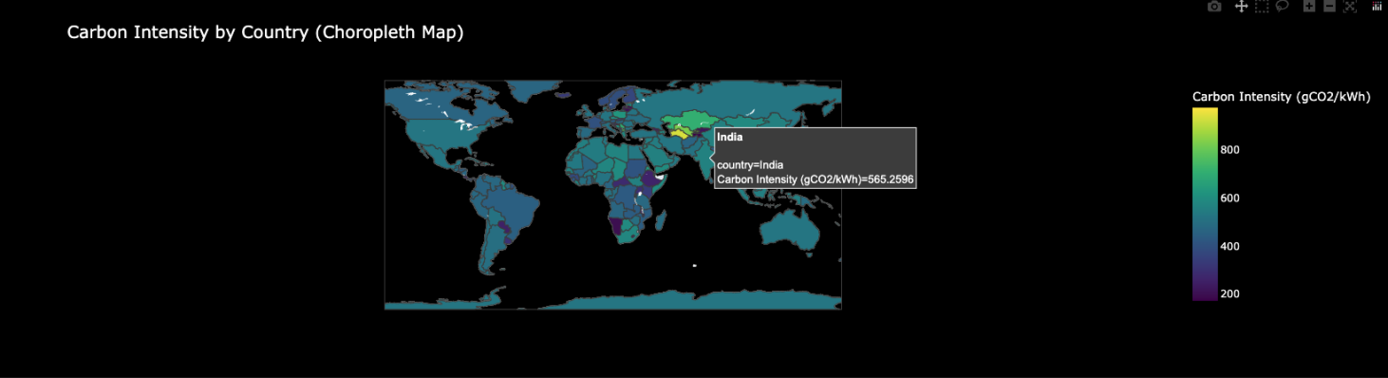

**[9]**

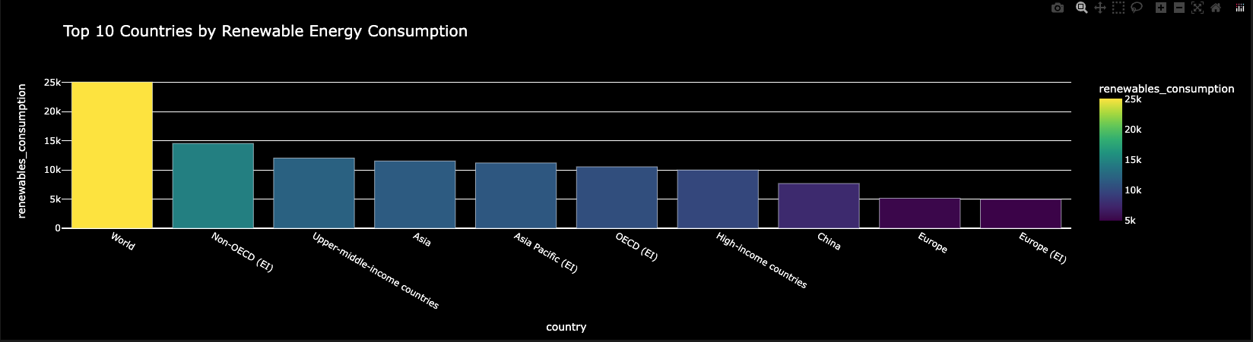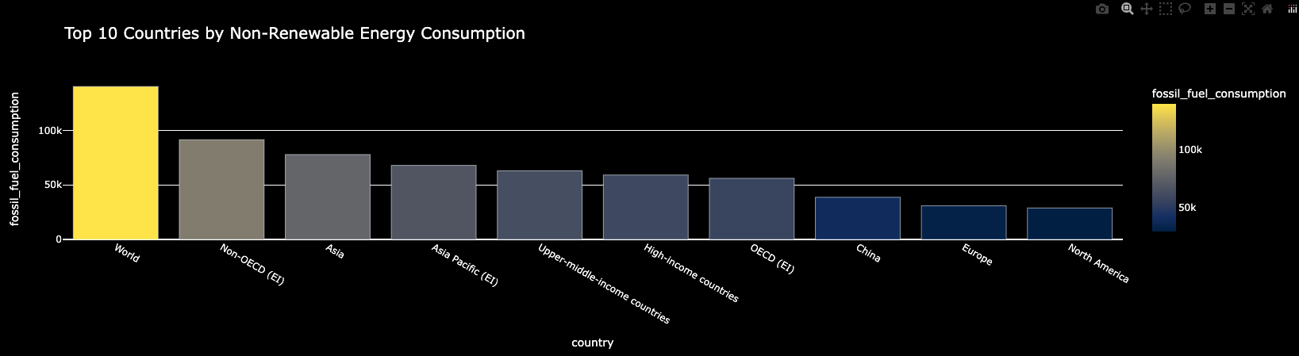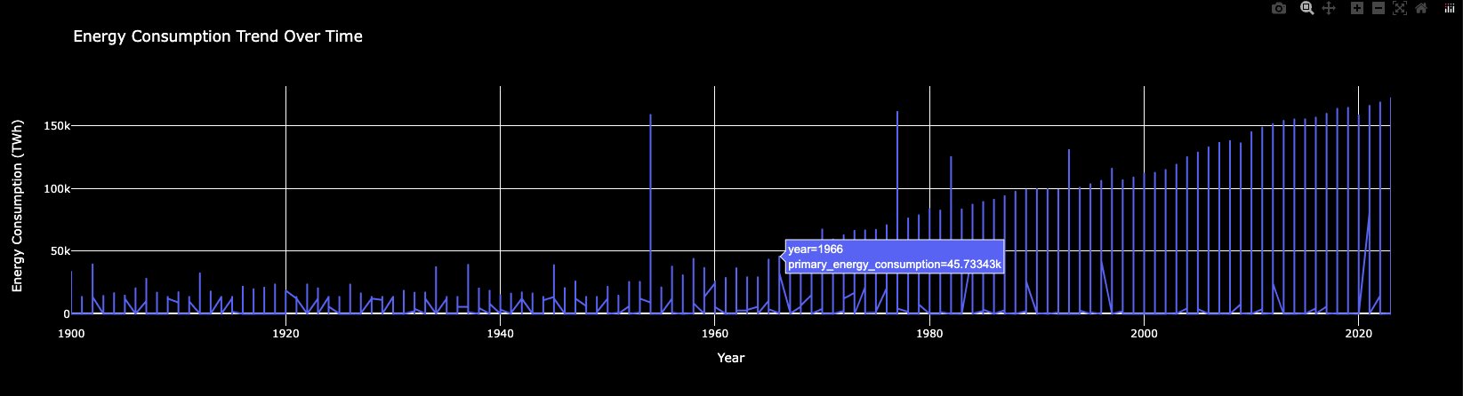

**[10]**

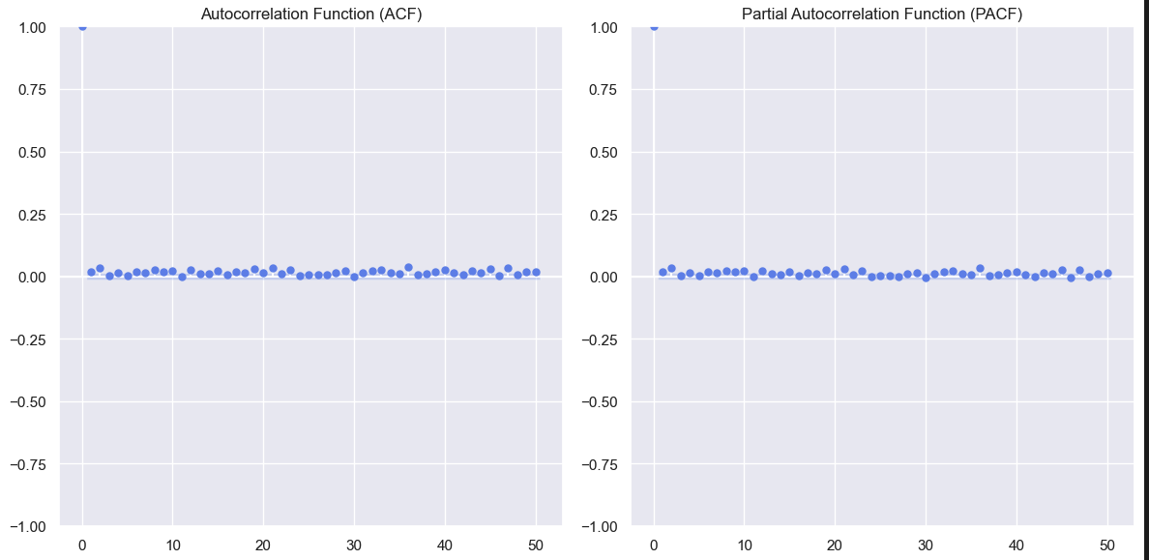

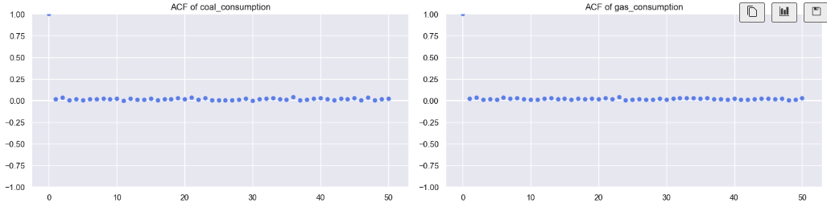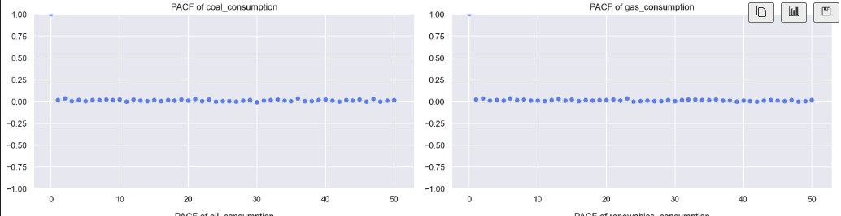

**[11]**

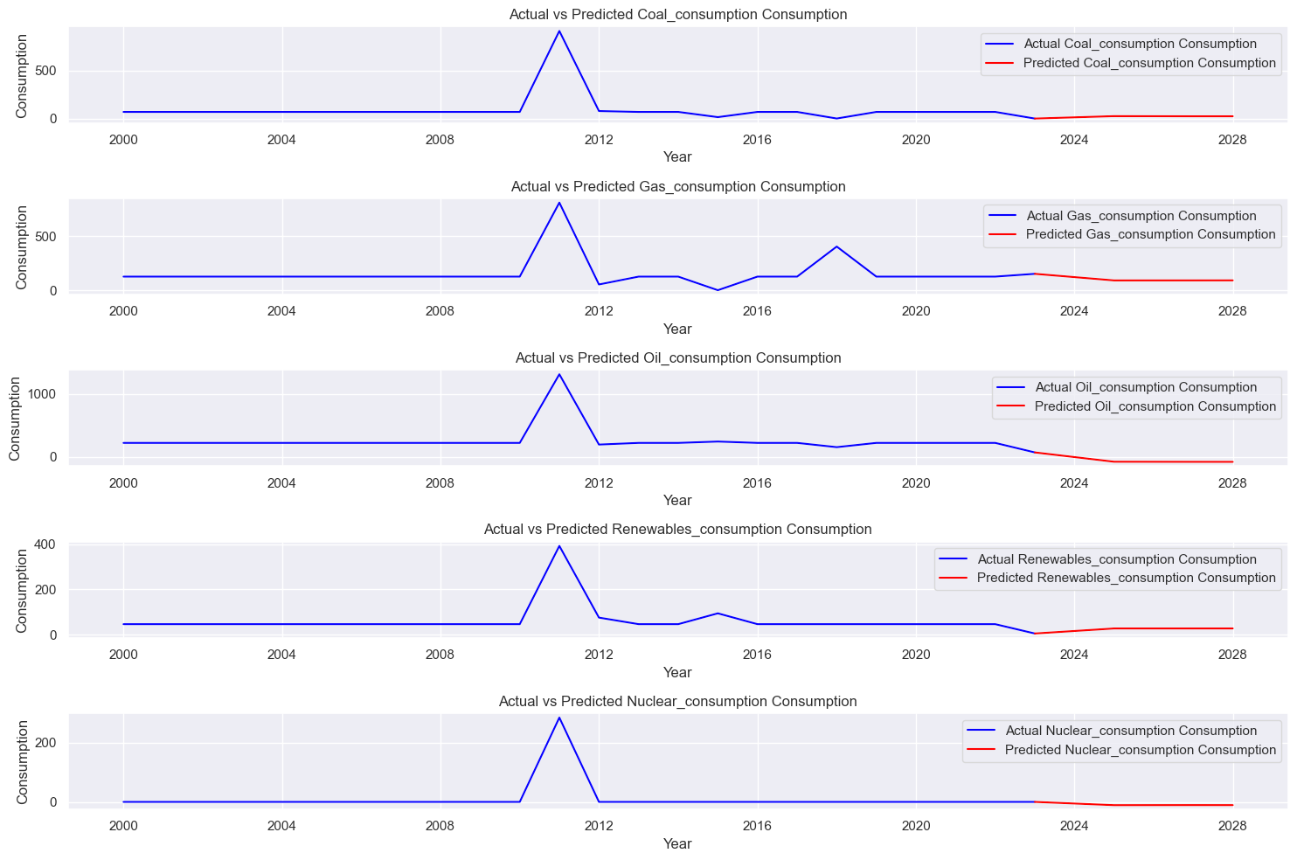

**[12]**

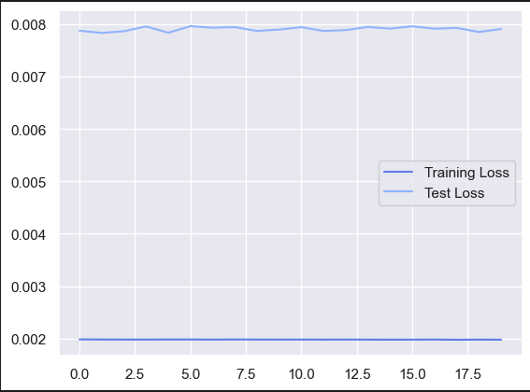

1. **TABLEAU DASHBOARD:**

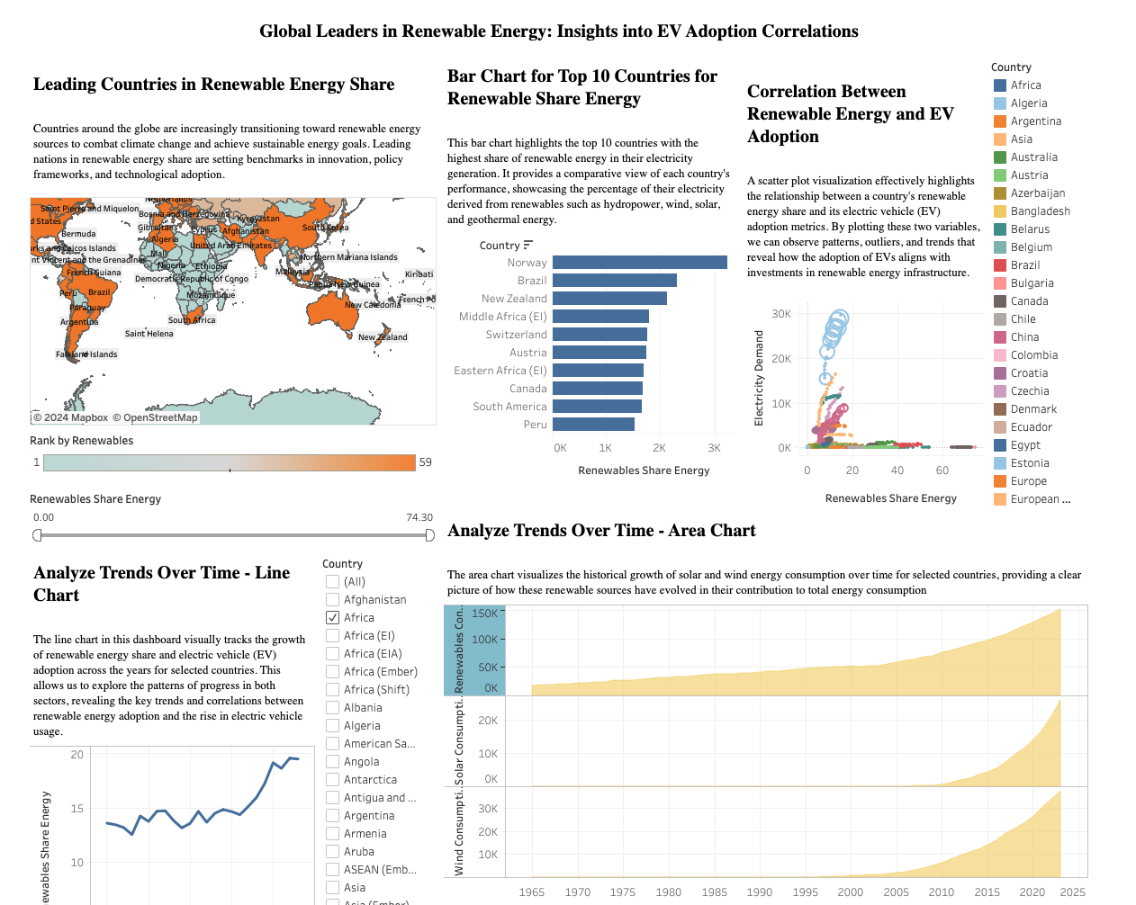

1. **POWERBI DASHBOARD:**

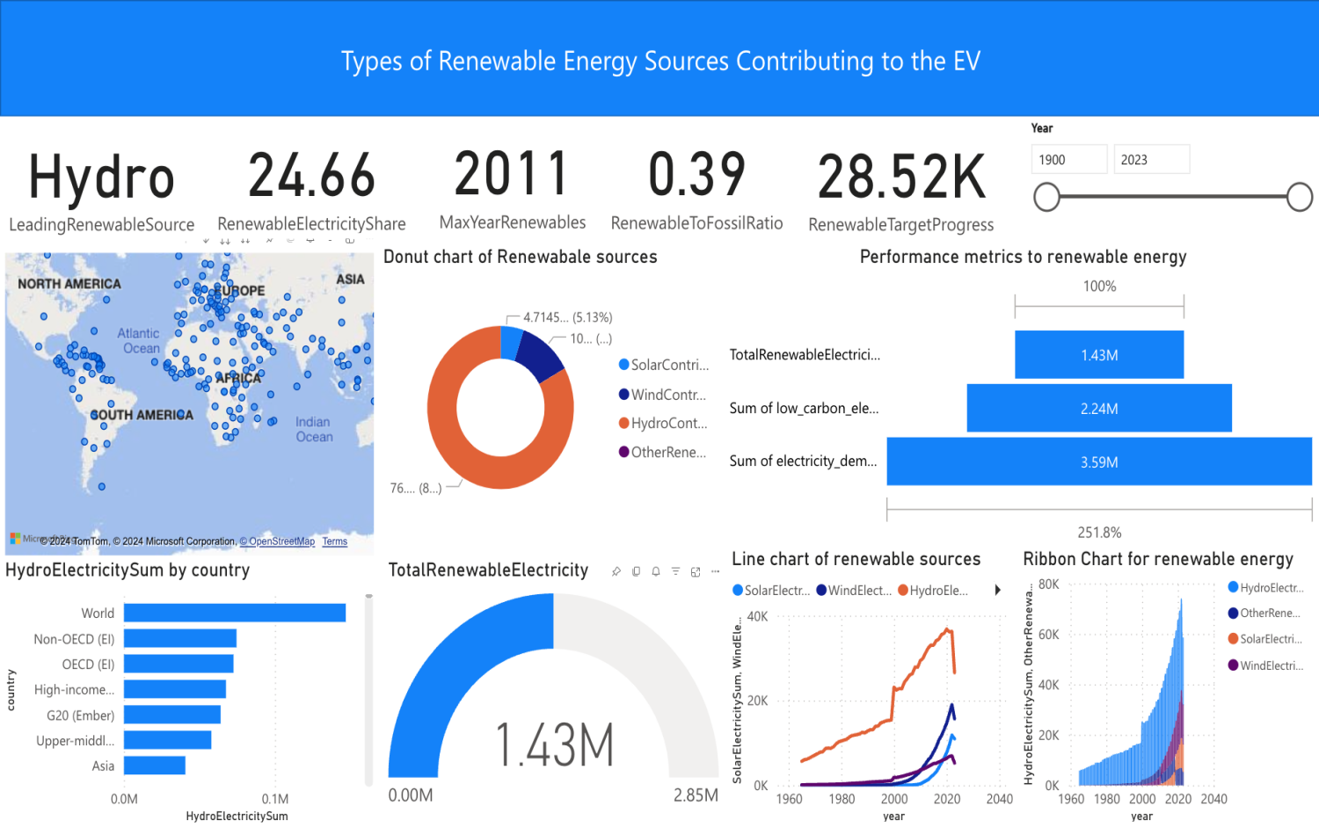

1. **POSTER:**

